1. [](http://www.google.co.uk/url?sa=i&rct=j&q=status+symbols+examples&source=images&cd=&cad=rja&uact=8&ved=&url=http%3A%2F%2Fwww.peachparts.com%2Fshopforum%2Fopen-discussion%2F358122-list-merican-status-symbols.html&ei=Y9S3VKTANonVapn7gPAG&bvm=bv.83640239,d.d2s&psig=AFQjCNE5u3tNh9igJtnKZ0eTiElEHgnV_g&ust=1421420004712182)

[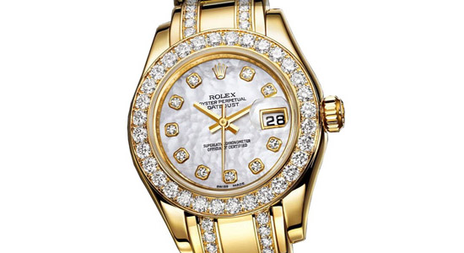](http://www.google.co.uk/url?sa=i&rct=j&q=status+symbols+examples&source=images&cd=&ved=0CAcQjRw&url=http://www.designdb.com/dtrend/trend.l.asp?order%3Dnew%26dStyle%3Dblog%26MenuCode%3D%26menupkid%3D234%26keyword%3D%26relation_keyword%3D%26pkid%3D%26cate_idx%3D%26Category%3D%26page%3D41&ei=INW3VKHQKIjjatLcgcgL&bvm=bv.83640239,d.d2s&psig=AFQjCNE5u3tNh9igJtnKZ0eTiElEHgnV_g&ust=1421420004712182)

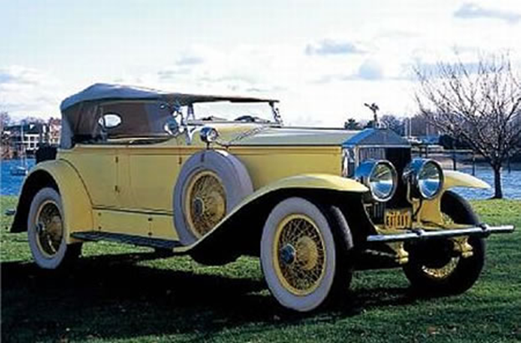

[](http://www.google.co.uk/url?sa=i&rct=j&q=status+symbols+examples&source=images&cd=&cad=rja&uact=8&ved=0CAcQjRw&url=http%3A%2F%2Ftrendwatching.com%2Ftrends%2F7trends2014%2F&ei=qdW3VI7FJ4bkapHUgcAD&bvm=bv.83640239,d.d2s&psig=AFQjCNE5u3tNh9igJtnKZ0eTiElEHgnV_g&ust=1421420004712182)

[](http://www.google.co.uk/url?sa=i&rct=j&q=private+jets&source=images&cd=&cad=rja&uact=8&ved=0CAcQjRw&url=http%3A%2F%2Fedition.cnn.com%2F2012%2F11%2F29%2Fbusiness%2Fafrica-business-aviation%2F&ei=RNa3VLm3BMHcas-XgdgL&bvm=bv.83640239,d.d2s&psig=AFQjCNEgx1-uIEZIOpCb9OgQd9qlLQ_RyQ&ust=1421420474674180)

[](http://www.google.co.uk/url?sa=i&rct=j&q=beautiful+women&source=images&cd=&cad=rja&uact=8&ved=0CAcQjRw&url=http%3A%2F%2Fhollywoodbuzz.buzznet.com%2Fuser%2Fjournal%2F17410302%2Fofficial-top-30-worlds-most%2F&ei=mda3VKvfPMXbaN-hgcgM&bvm=bv.83640239,d.d2s&psig=AFQjCNHksjiB22QjYE176Lp5PQRssm19YA&ust=1421420526608521)